Silhouette metric for img011001.jpg is: 0.9796540942392157

Davies Bouldin metric for img011001.jpg is: 0.02767522580879675

Calinski Harabasz metric for img011001.jpg is: 901332.8070951201

ID 0: (1736, 445)

ID 1: (1087, 177)

ID 2: (965, 291)

ID 3: (915, 413)

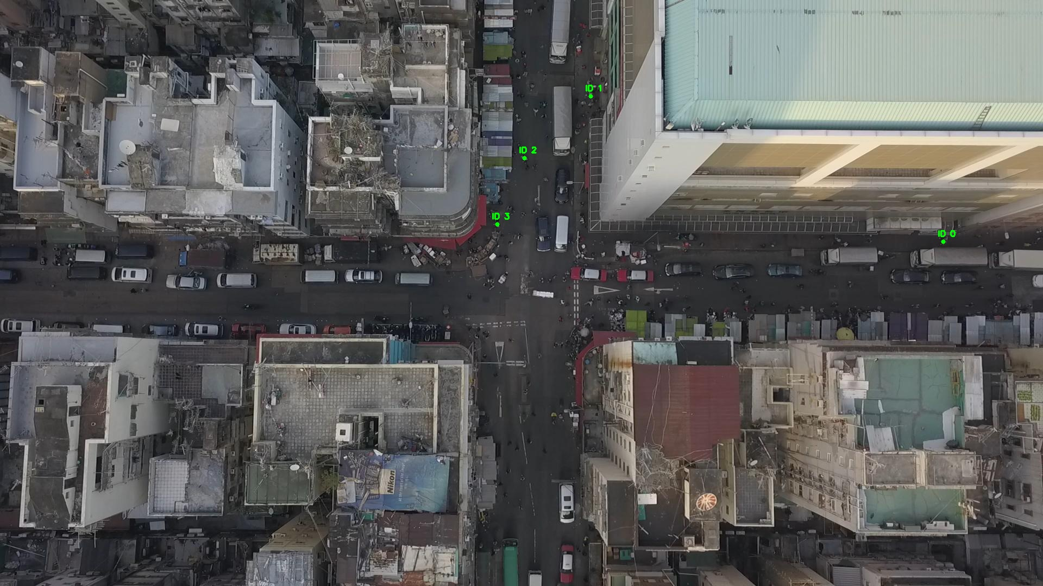

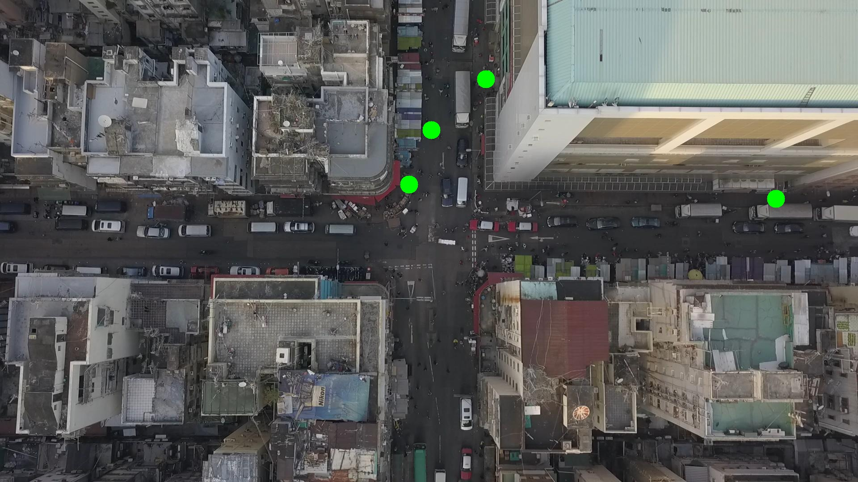

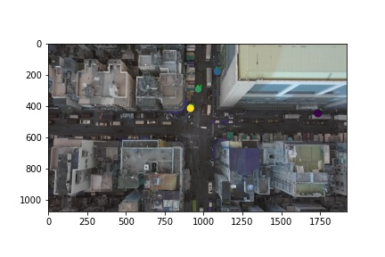

Silhouette metric for img011002.jpg is: 0.9013541217343254

Davies Bouldin metric for img011002.jpg is: 0.11943068229094016

Calinski Harabasz metric for img011002.jpg is: 8120.136763454029

ID 0: (1142, 557)

ID 1: (1087, 178)

ID 2: (997, 193)

ID 3: (889, 440)

ID 4: (937, 815)

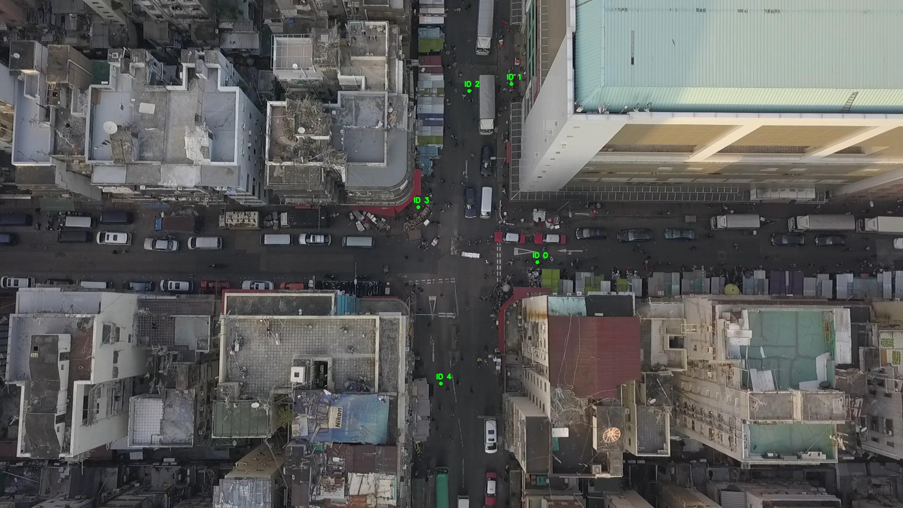

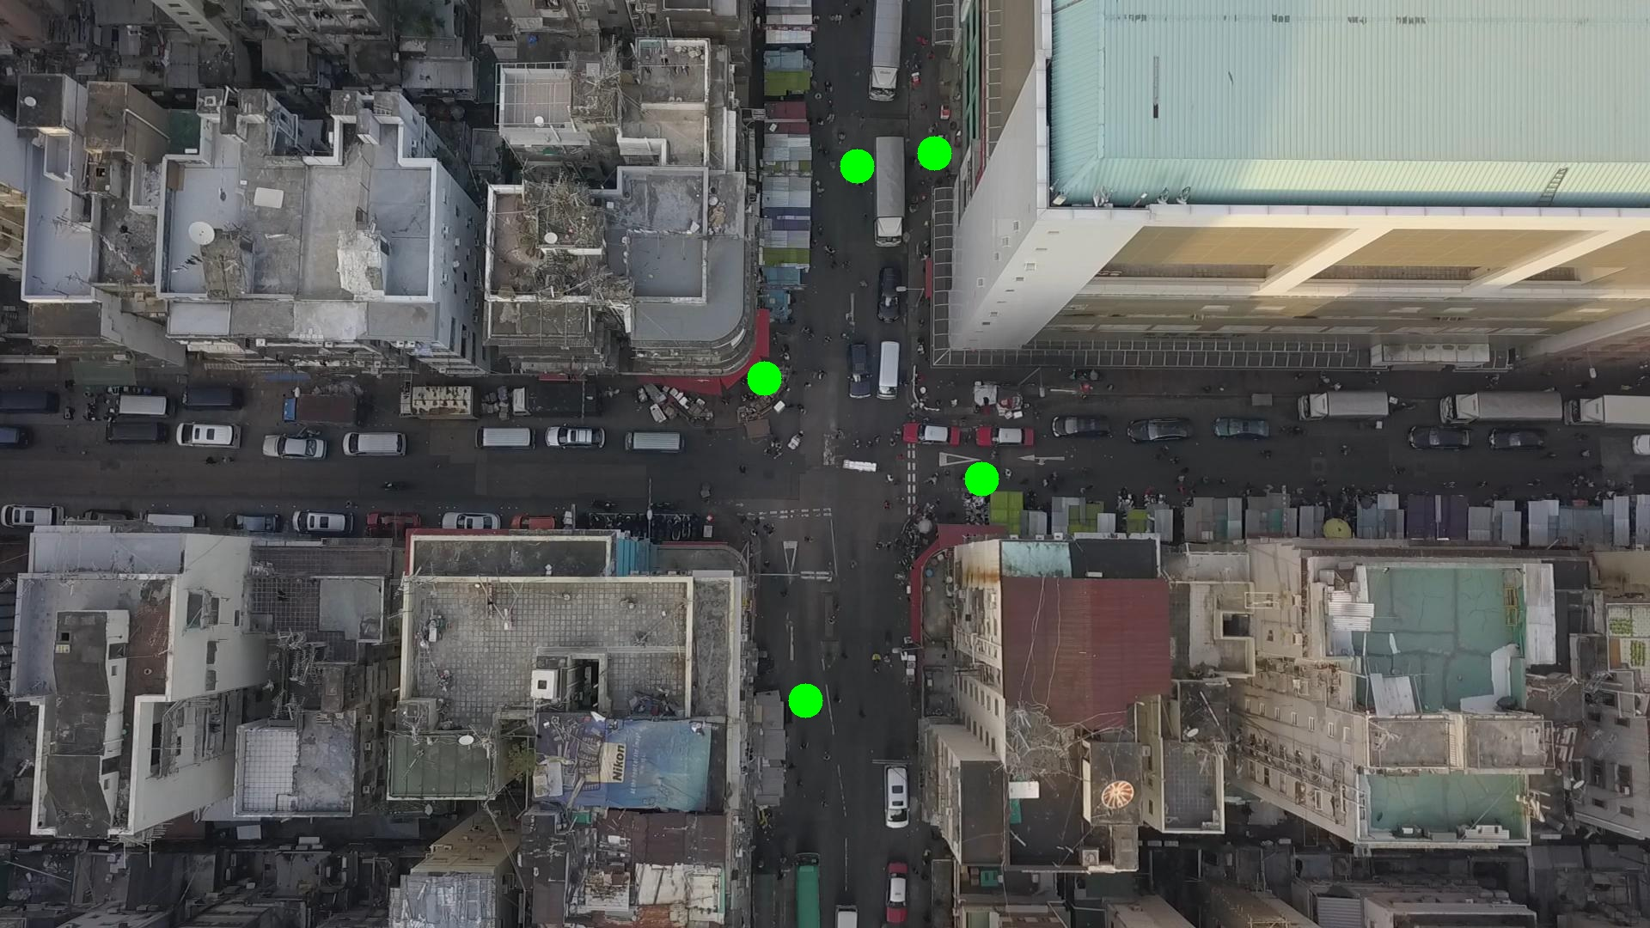

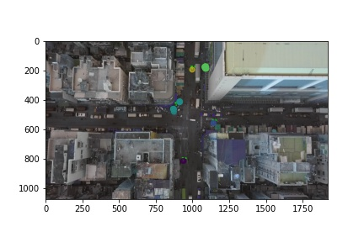

Silhouette metric for img011003.jpg is: 0.8966621870893718

Davies Bouldin metric for img011003.jpg is: 0.14963043730004585

Calinski Harabasz metric for img011003.jpg is: 11447.204827087351

ID 0: (1142, 557)

ID 1: (1087, 178)

ID 2: (997, 193)

ID 3: (892, 436)

ID 4: (937, 815)

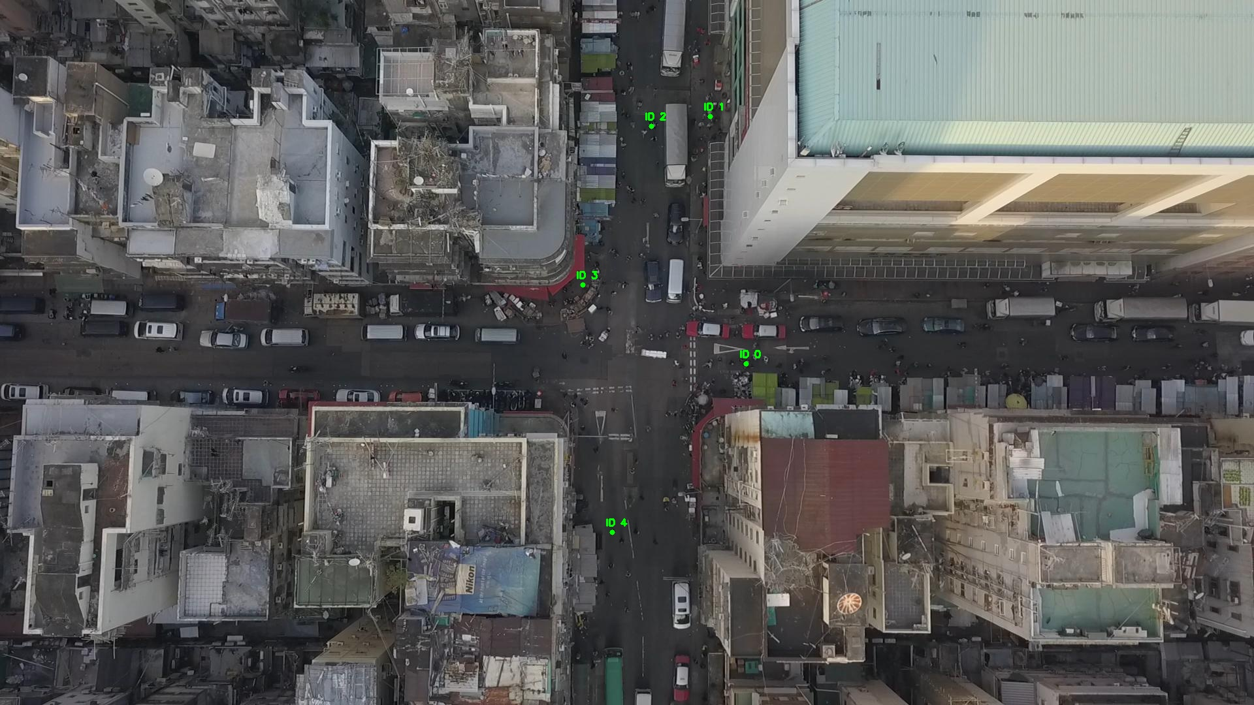

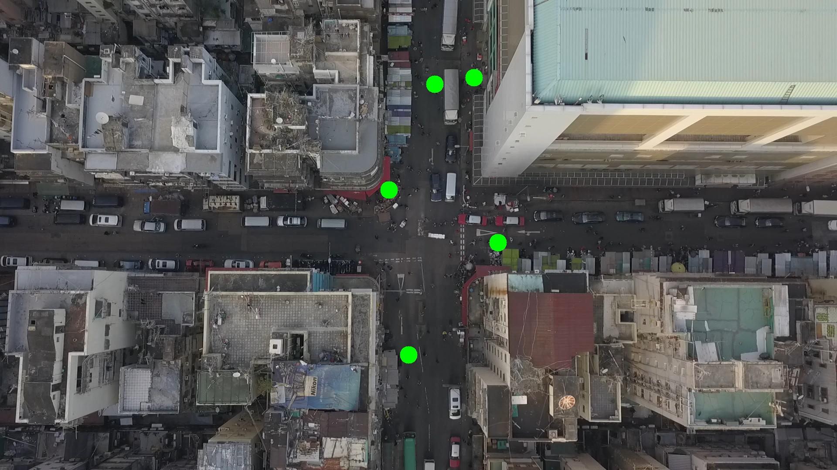

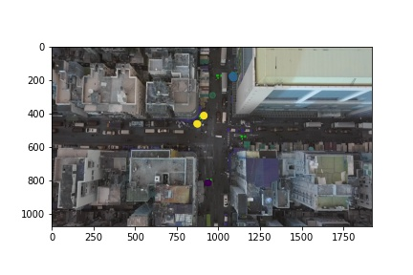

Silhouette metric for img011004.jpg is: 0.881119622029327

Davies Bouldin metric for img011004.jpg is: 0.17155207861661687

Calinski Harabasz metric for img011004.jpg is: 5342.779099694888

ID 0: (1142, 557)

ID 1: (1087, 180)

ID 2: (997, 193)

ID 3: (889, 439)

ID 4: (937, 815)

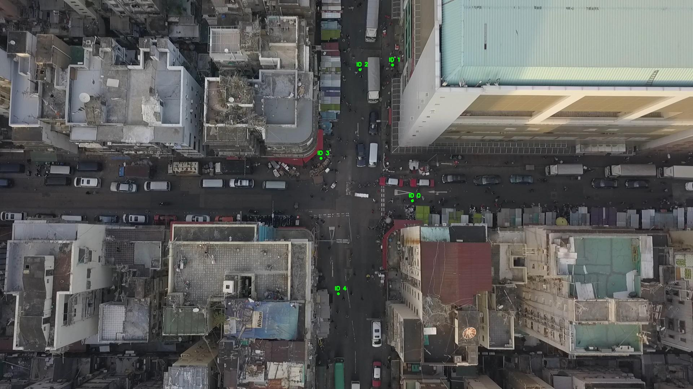

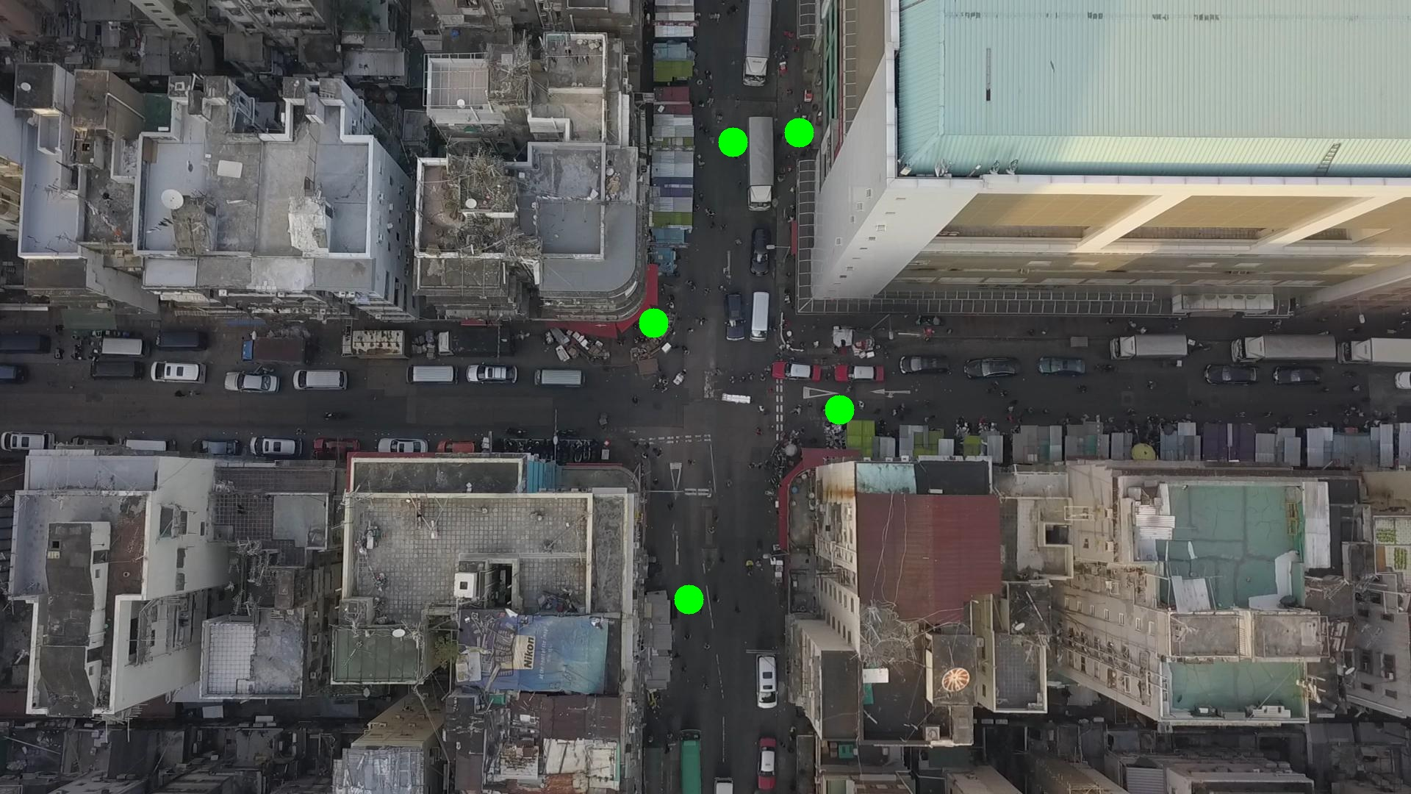

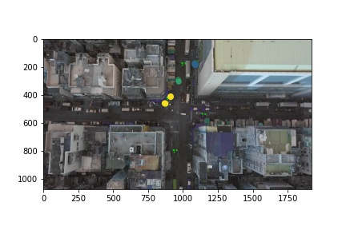

Silhouette metric for img011005.jpg is: 0.757800154685997

Davies Bouldin metric for img011005.jpg is: 0.2514962875652432

Calinski Harabasz metric for img011005.jpg is: 8172.652039406633

ID 0: (1112, 575)

ID 1: (1059, 184)

ID 2: (997, 193)

ID 3: (935, 359)

ID 4: (937, 813)

ID 5: (96, 478)

ID 6: (1376, 554)

ID 7: (891, 654)

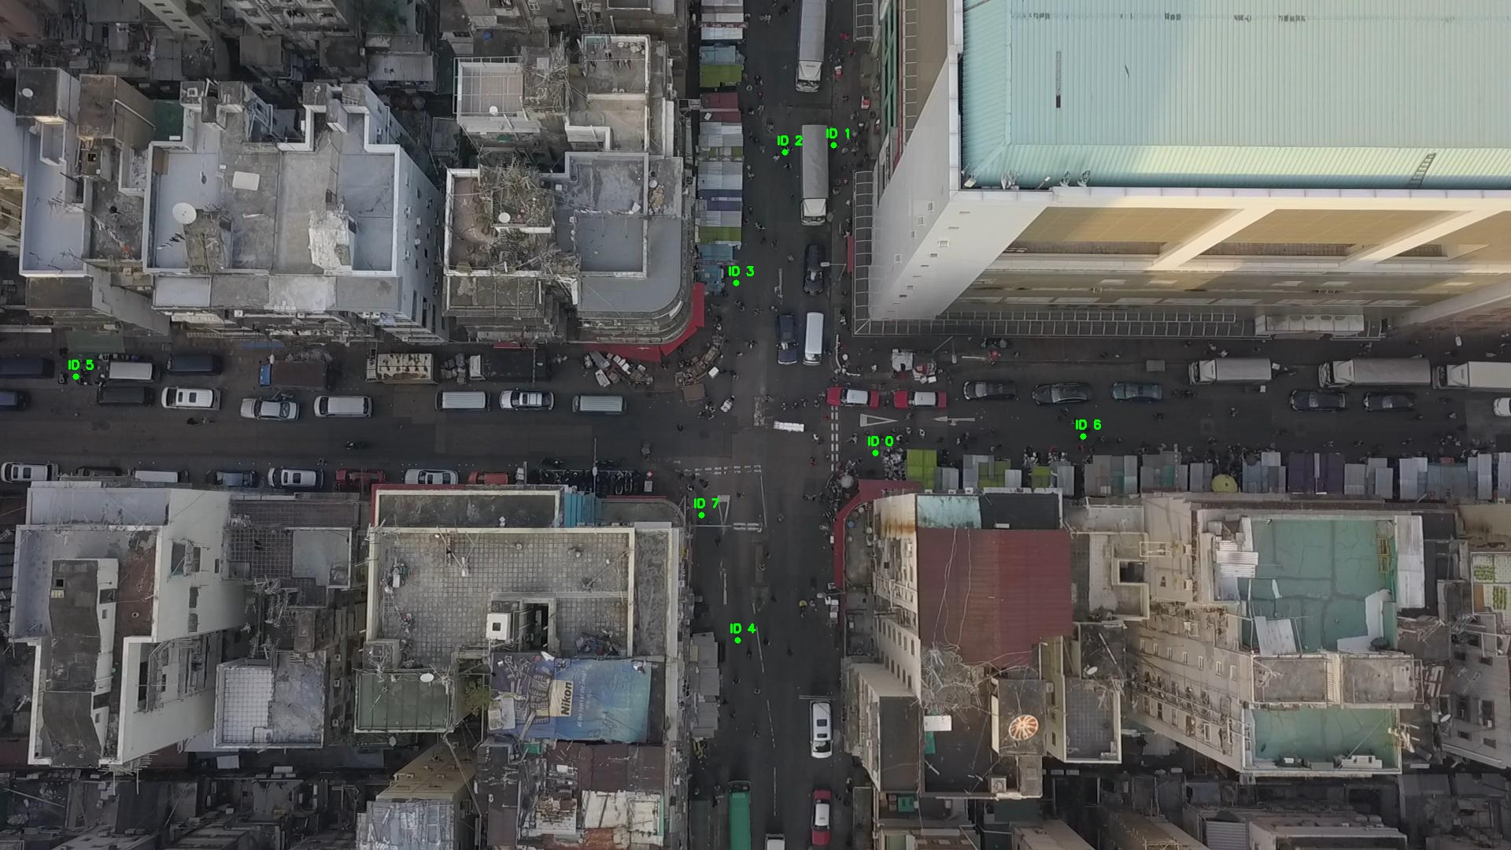

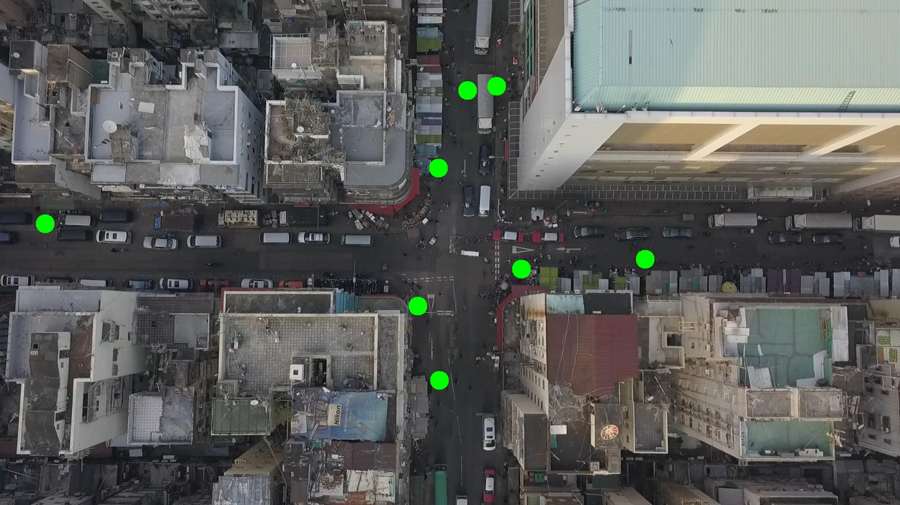

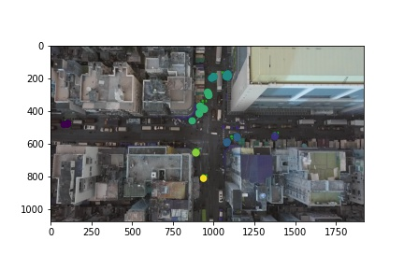

Silhouette metric for img011006.jpg is: 0.6676071897476838

Davies Bouldin metric for img011006.jpg is: 0.2861983004652345

Calinski Harabasz metric for img011006.jpg is: 4898.053403165188

ID 0: (1128, 577)

ID 1: (1059, 184)

ID 2: (997, 193)

ID 3: (977, 290)

ID 4: (937, 811)

ID 5: (97, 477)

ID 6: (1366, 544)

ID 7: (891, 654)

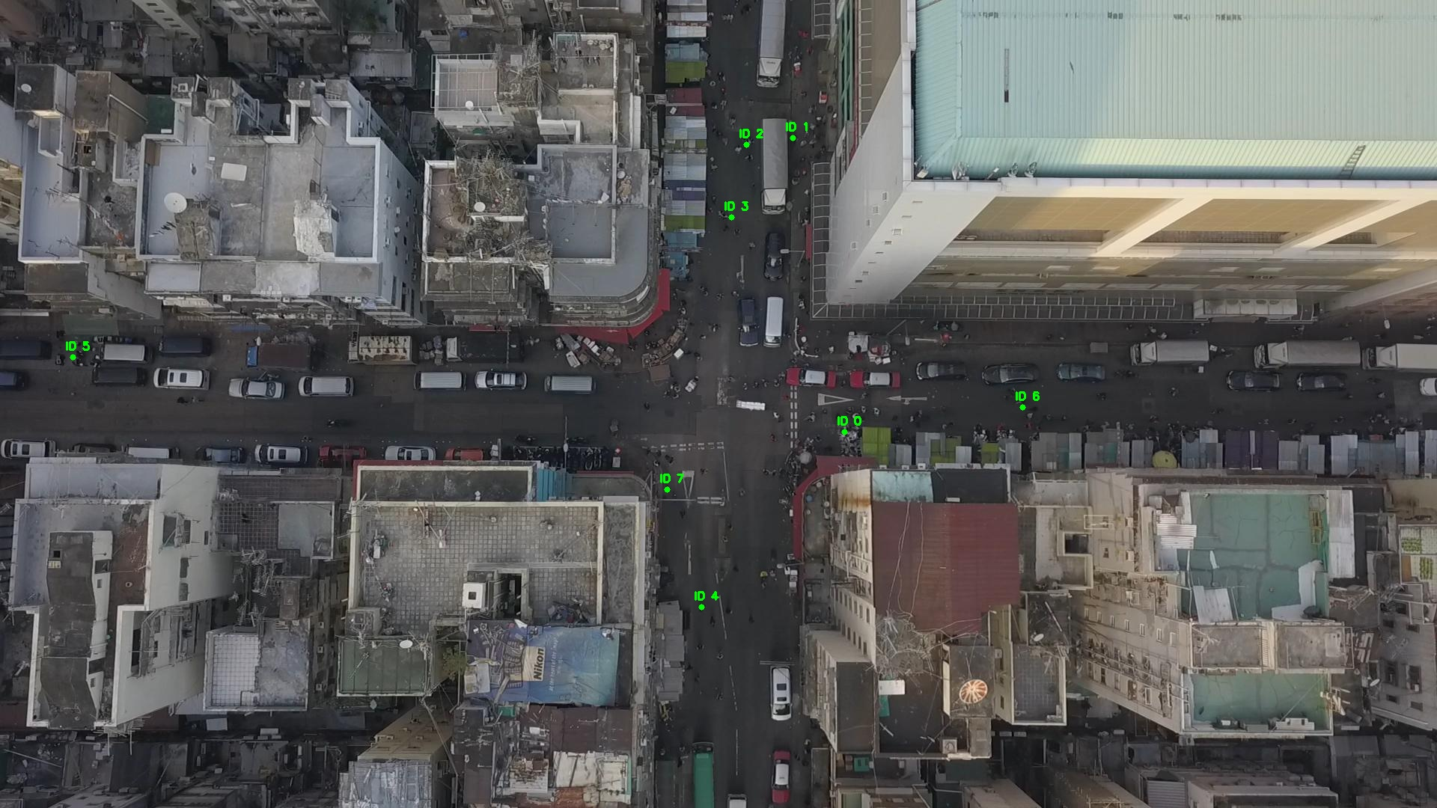

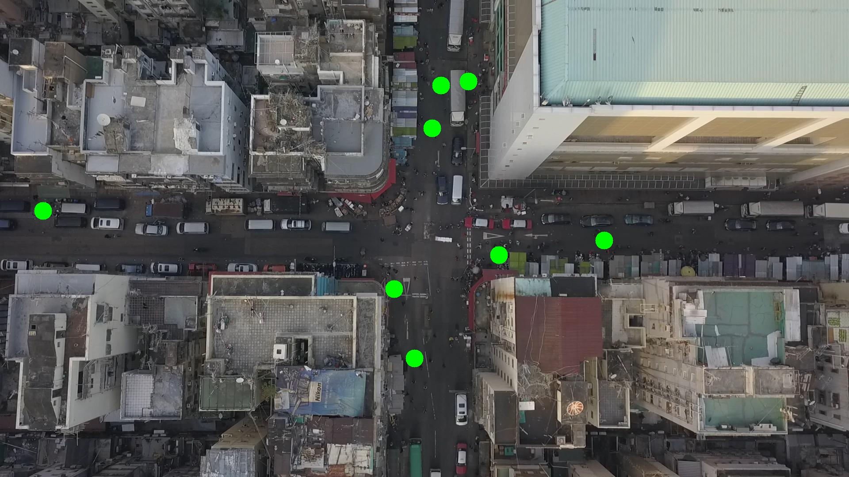

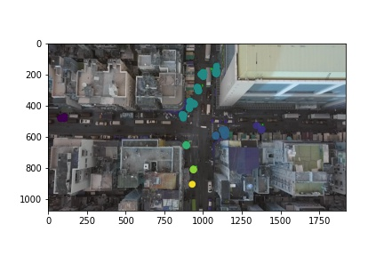

Silhouette metric for img011007.jpg is: 0.6171454620495539

Davies Bouldin metric for img011007.jpg is: 0.2886447743828662

Calinski Harabasz metric for img011007.jpg is: 4437.981393146578

ID 0: (1118, 579)

ID 1: (1059, 184)

ID 2: (997, 193)

ID 3: (983, 286)

ID 4: (937, 811)

ID 5: (92, 477)

ID 6: (1377, 553)

ID 7: (891, 654)

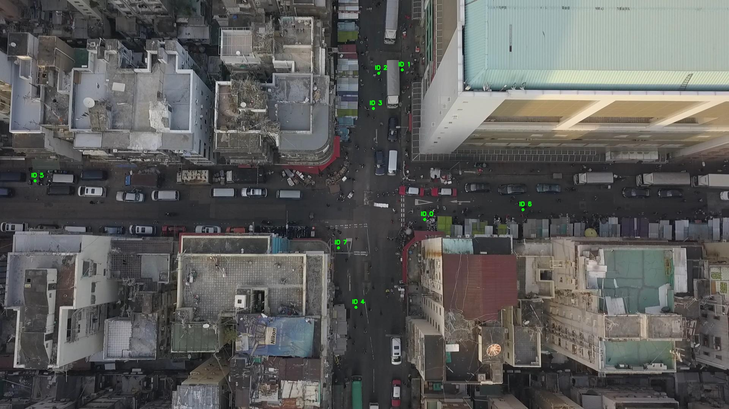

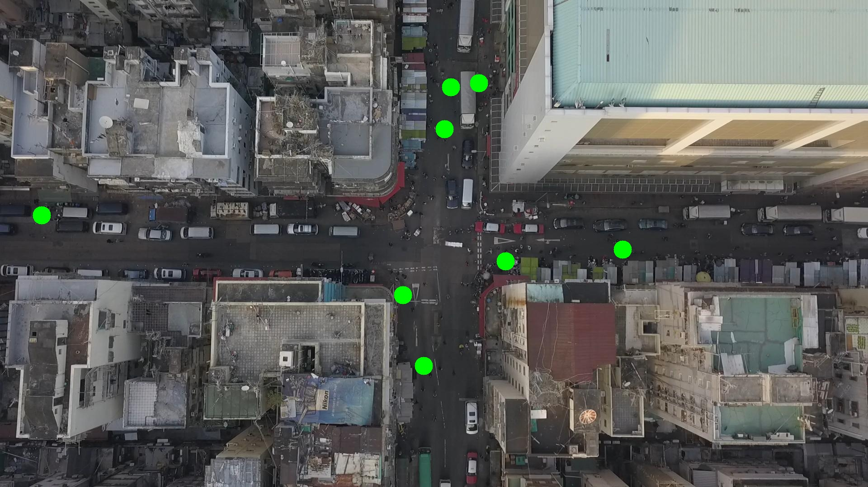

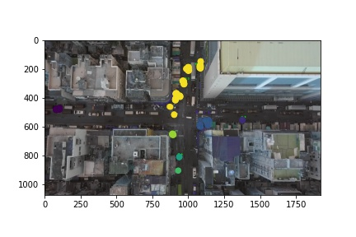

Silhouette metric for img011008.jpg is: 0.4221003551609983

Davies Bouldin metric for img011008.jpg is: 0.3848296808146087

Calinski Harabasz metric for img011008.jpg is: 3940.751498703545

ID 0: (1121, 578)

ID 1: (1059, 184)

ID 2: (997, 193)

ID 3: (992, 282)

ID 4: (930, 904)

ID 5: (89, 478)

ID 6: (1149, 467)

ID 7: (891, 653)

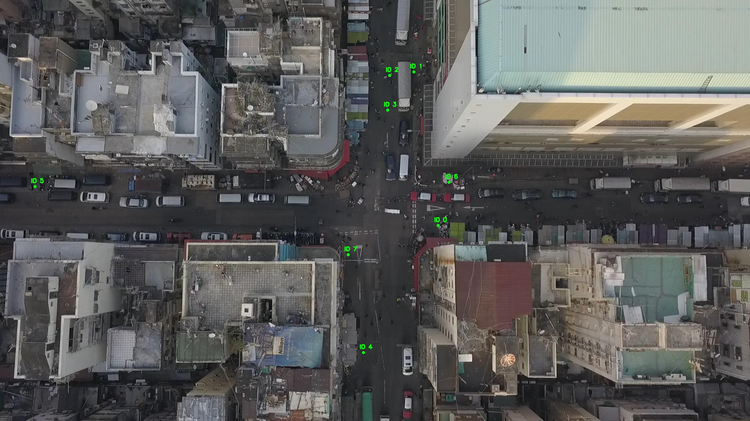

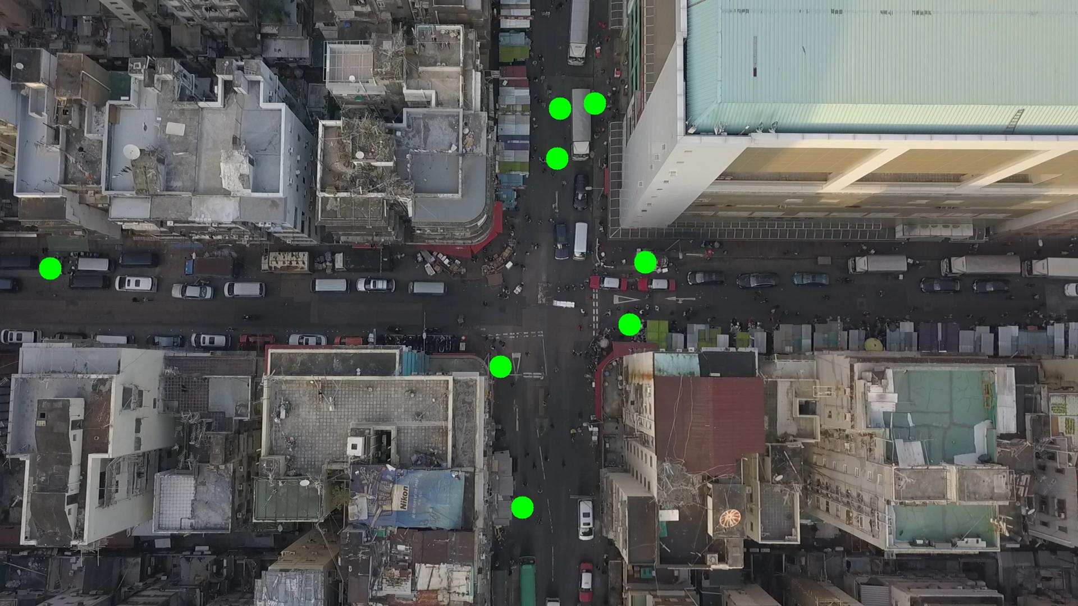

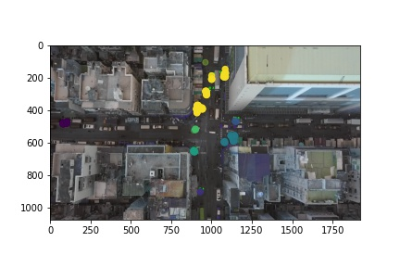

Silhouette metric for img011009.jpg is: 0.6650013765354922

Davies Bouldin metric for img011009.jpg is: 0.2666021545428583

Calinski Harabasz metric for img011009.jpg is: 9815.679978290938

ID 0: (1130, 581)

ID 1: (1059, 184)

ID 2: (997, 193)

ID 3: (970, 302)

ID 4: (1065, 1012)

ID 5: (96, 476)

ID 6: (1149, 467)

ID 7: (892, 525)

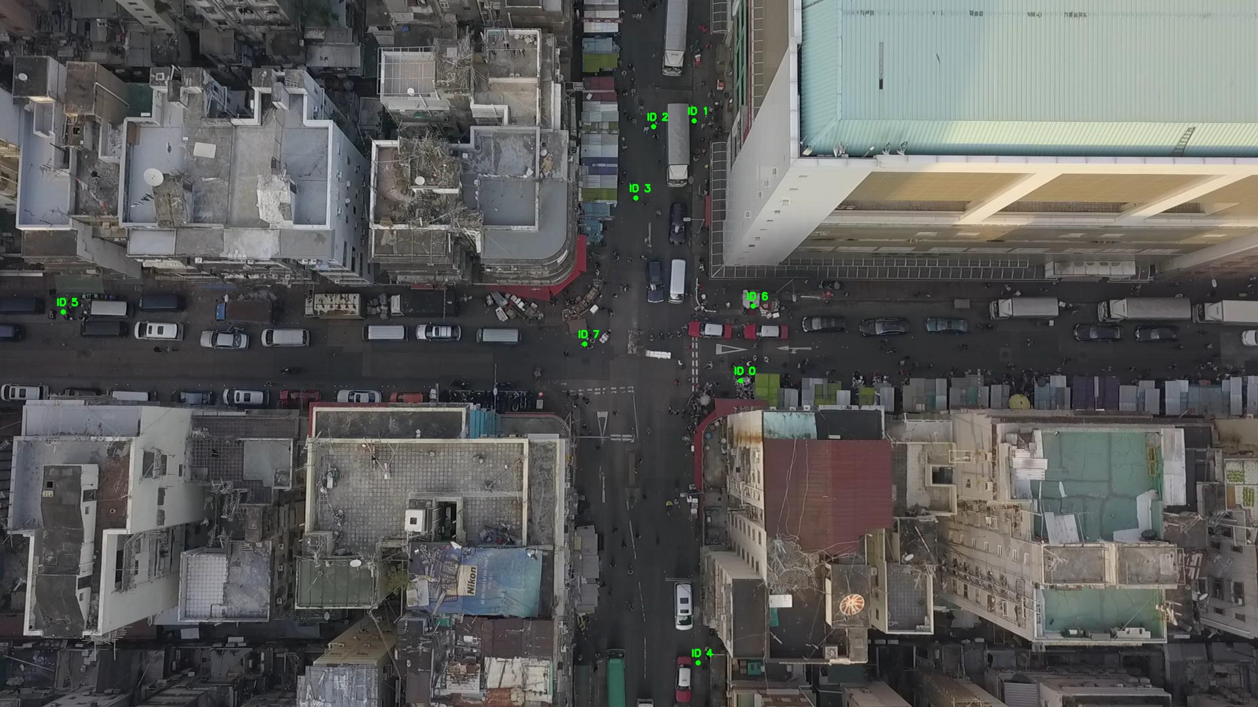

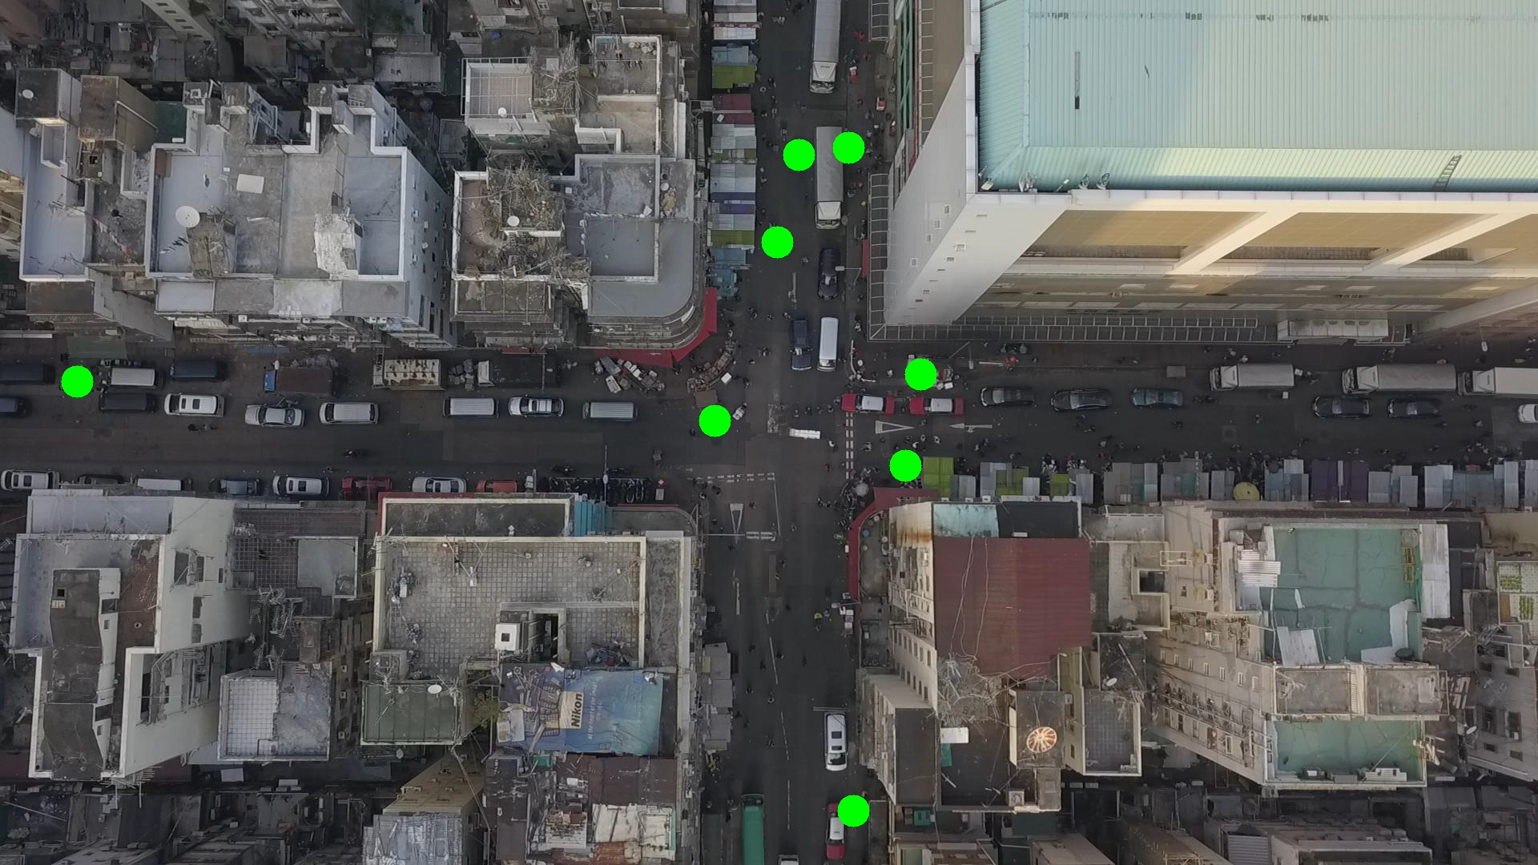

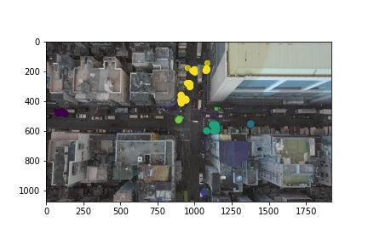

Silhouette metric for img011010.jpg is: 0.764918773287227

Davies Bouldin metric for img011010.jpg is: 0.20878154526099835

Calinski Harabasz metric for img011010.jpg is: 14266.052605257933

ID 0: (1127, 582)

ID 1: (1059, 184)

ID 2: (1024, 215)

ID 3: (970, 302)

ID 4: (1065, 1011)

ID 5: (86, 478)

ID 6: (1149, 467)

ID 7: (894, 526)

ID 8: (1237, 1045)

ID 9: (1378, 551)

ID 10: (892, 652)

ID 11: (920, 394)

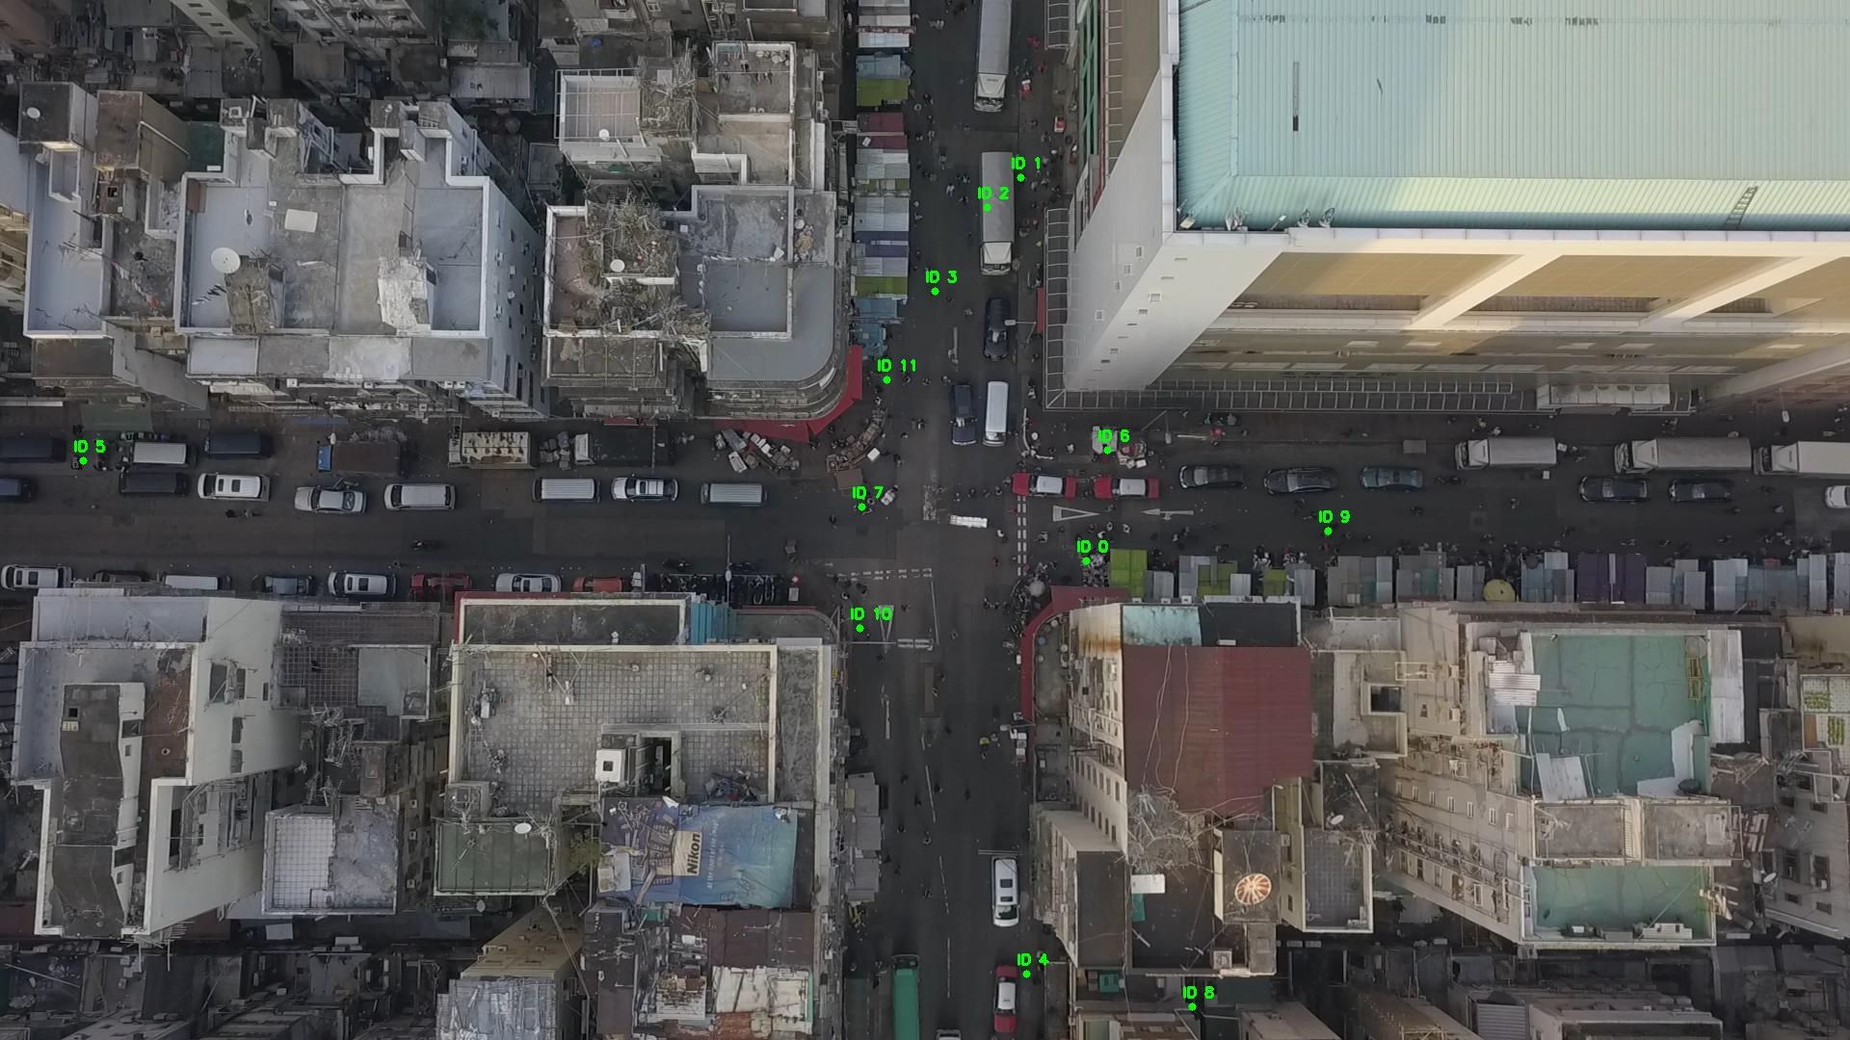

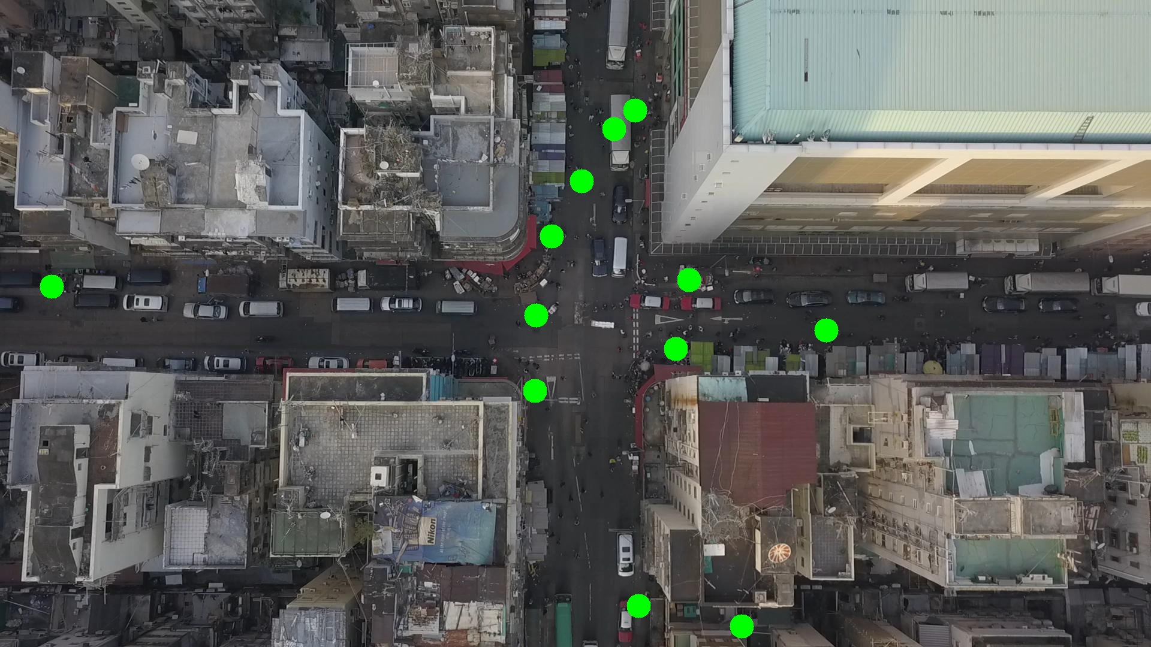

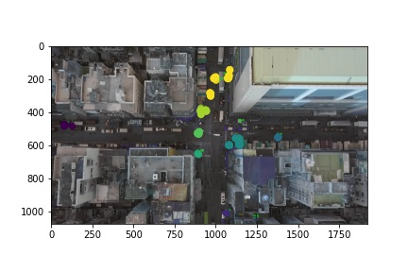

Silhouette metric for img011011.jpg is: 0.6167622438494885

Davies Bouldin metric for img011011.jpg is: 0.2923807419225471

Calinski Harabasz metric for img011011.jpg is: 4471.1610352684265

ID 0: (1130, 580)

ID 1: (1059, 184)

ID 2: (1024, 215)

ID 3: (984, 283)

ID 4: (1066, 1012)

ID 5: (87, 479)

ID 6: (1149, 467)

ID 7: (894, 527)

ID 8: (1237, 1045)

ID 9: (1378, 551)

ID 10: (891, 650)

ID 11: (920, 394)

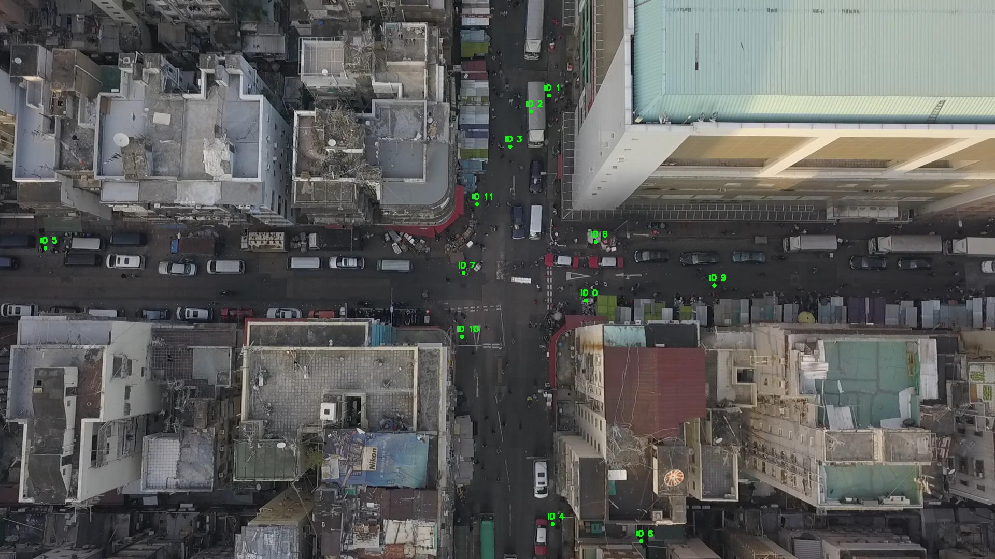

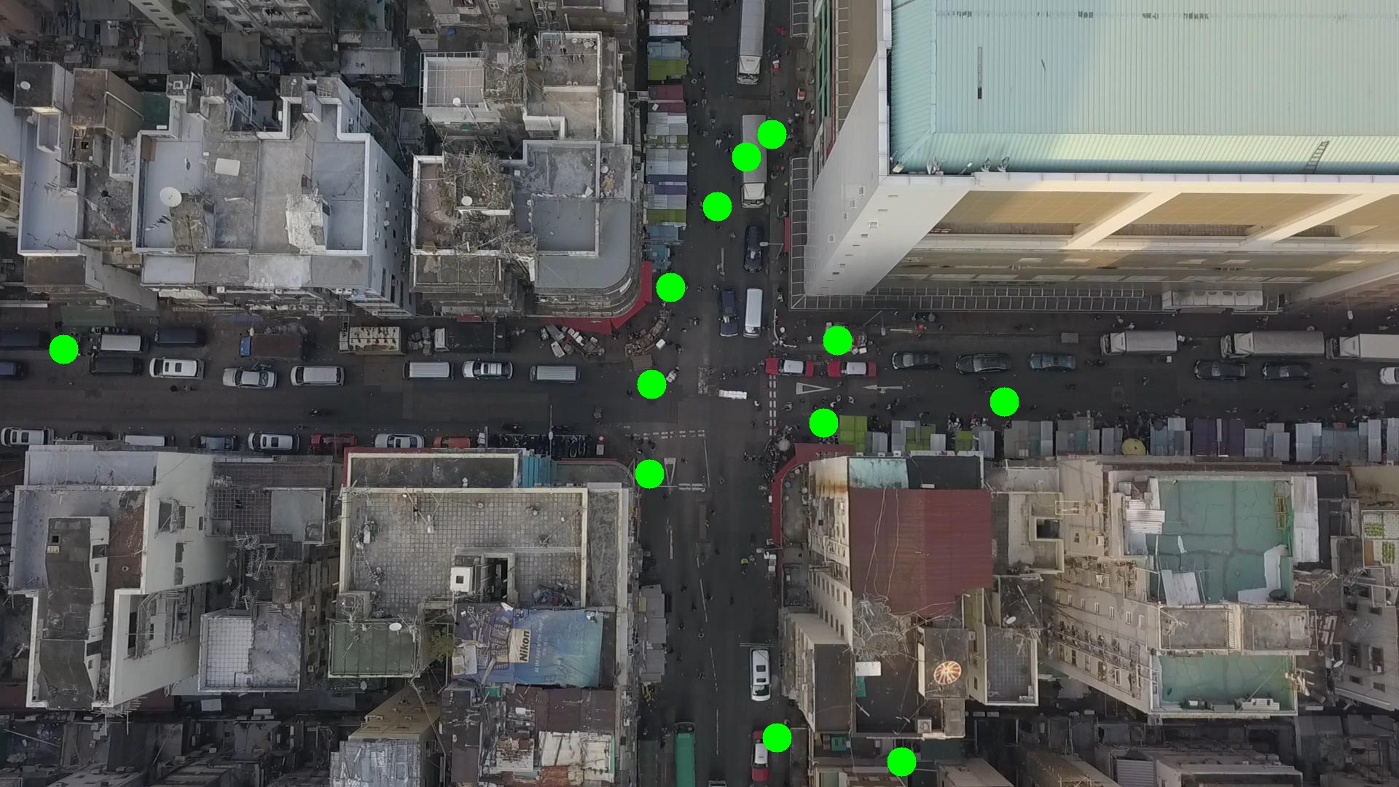

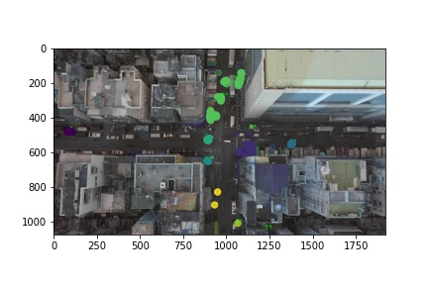

Silhouette metric for img011012.jpg is: 0.7562747308511122

Davies Bouldin metric for img011012.jpg is: 0.21004339960115304

Calinski Harabasz metric for img011012.jpg is: 14990.478177237608

ID 0: (1128, 582)

ID 1: (1059, 184)

ID 2: (1026, 211)

ID 3: (984, 283)

ID 4: (1065, 1011)

ID 5: (83, 479)

ID 6: (1149, 467)

ID 7: (889, 526)

ID 8: (1237, 1045)

ID 9: (1372, 543)

ID 10: (890, 650)

ID 11: (924, 391)

